Picture Tour of Mother Lode Preschool
Here is a quick picture tour of the main areas of our classroom. I wanted to share this to give prospective parents a chance to get familiar with the room before jumping into the program! Any questions you have can be asked by emailing rjoribello@gmail.com. Thank you for your interest!

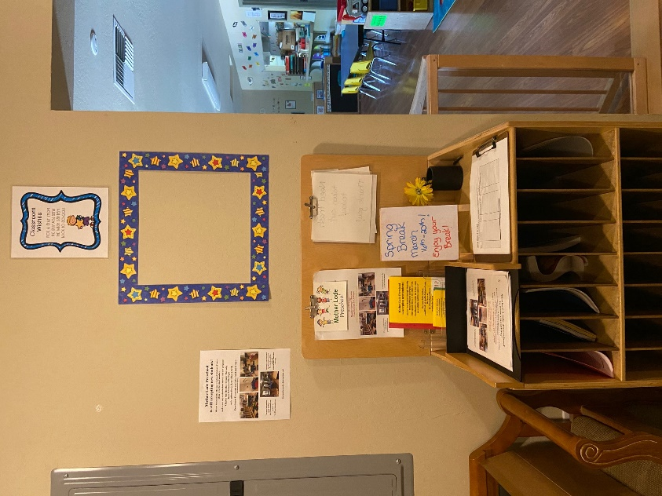
Here is the first stop in our tour, the sign in area that is in our entryway. This is where the daily sign in sheet is located, and there are also announcements posted here and flyers kept here for anyone to take. On the wall is our classroom wishes. This is where I will hang items that we might need in the classroom on little paper stars. Take a star, grant the wish, and return it to the classroom! Right now, though, we don’t need any supplies or classroom items. Just need students!

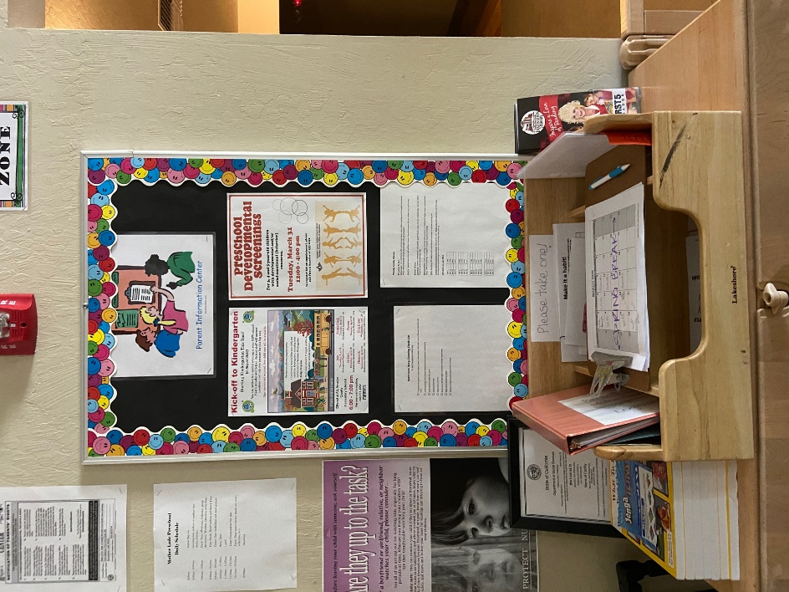

This is our Parent Information Center. It is located right inside the classroom to the right (next to the cubbies). Here is where the volunteer log book and calendar are kept. There will also be flyers posted on the bulletin board from time to time telling of upcoming workshops or events in the area. The list of required chores for our classroom is posted here as well. There is lots of other important information hanging on a separate bulletin board right next to the info center as well. It is vital for our parents to be checking out the info center on a regular basis, to keep up with any changes or needs in the classroom.

This is our Dramatic Play Center. We have a fully stocked play kitchen, lots of fun dress up clothes of boys and girls, a grocery store playset, and a tool bench playset. We also change it up once in a while and add new things for the children to explore! 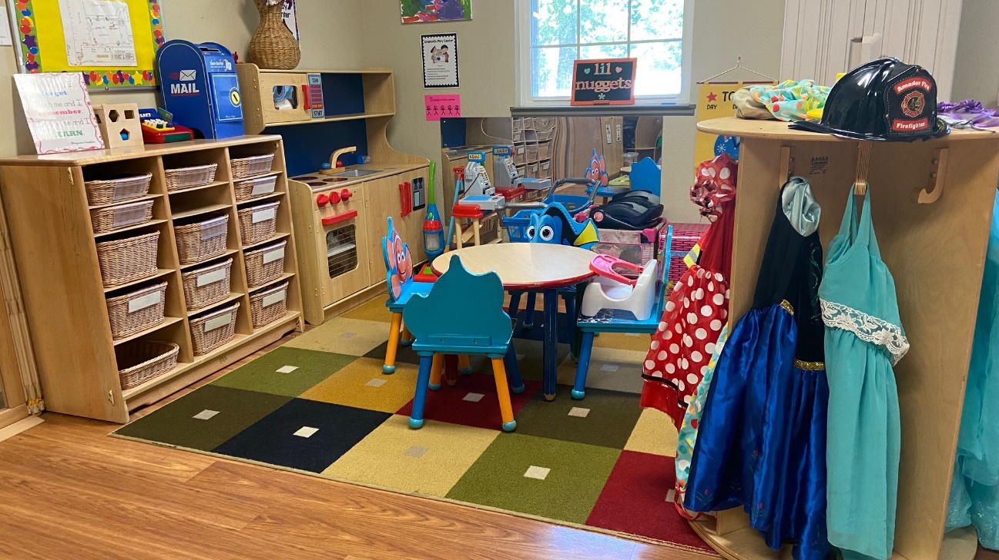
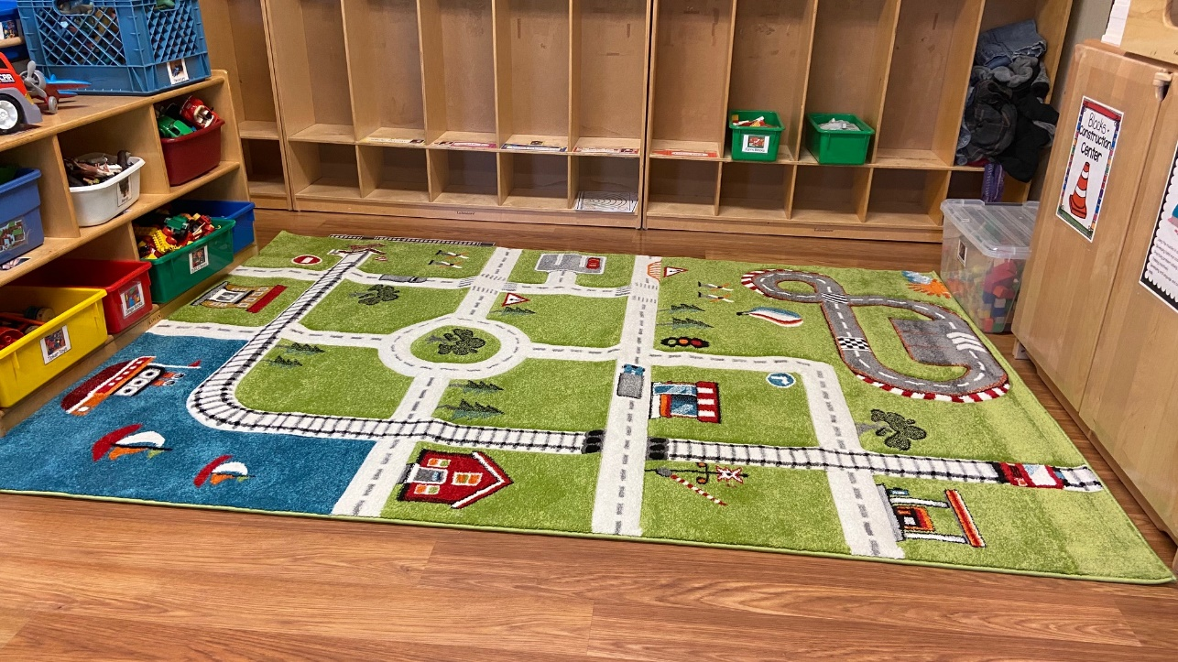
This is our Cars and Construction (blocks) Center. We have many different types of building toys and lots of cars and trucks for the students to use. We just got a brand-new play rug for this area right before the quarantine started. It hasn’t even been played on yet! You can also see our cubbies in this picture. We have enough cubbies for each child to have their own. Each student will keep a change of clothes in their cubby, as well as their lunch box and a jacket, when necessary. The bottom portion of the cubby is where I put work/art that has been completed and needs to go home, or notes to the families, etc.
Another view of the cubbies. Each one is labeled with the child’s full name and their picture, so they always know which one is theirs. 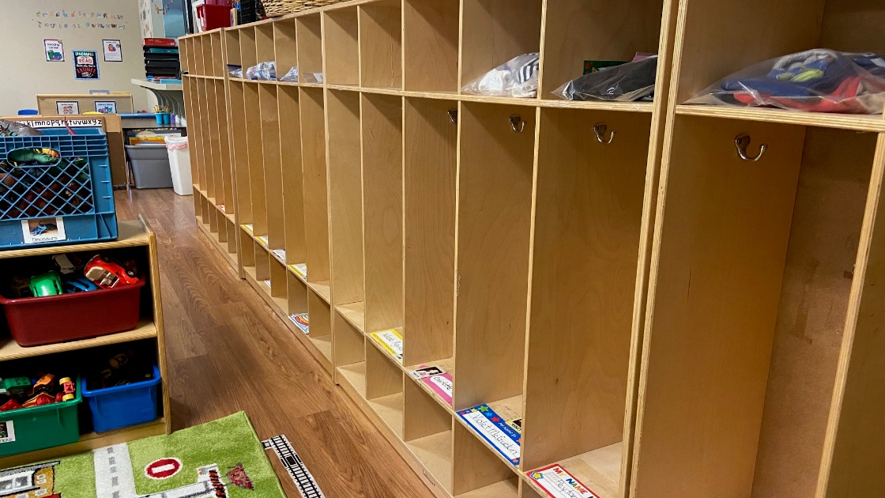
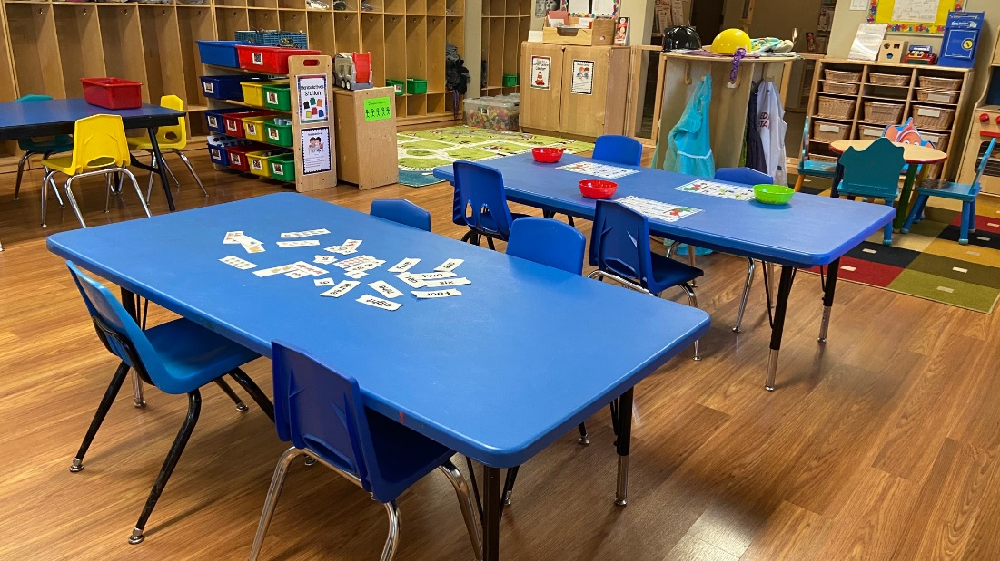
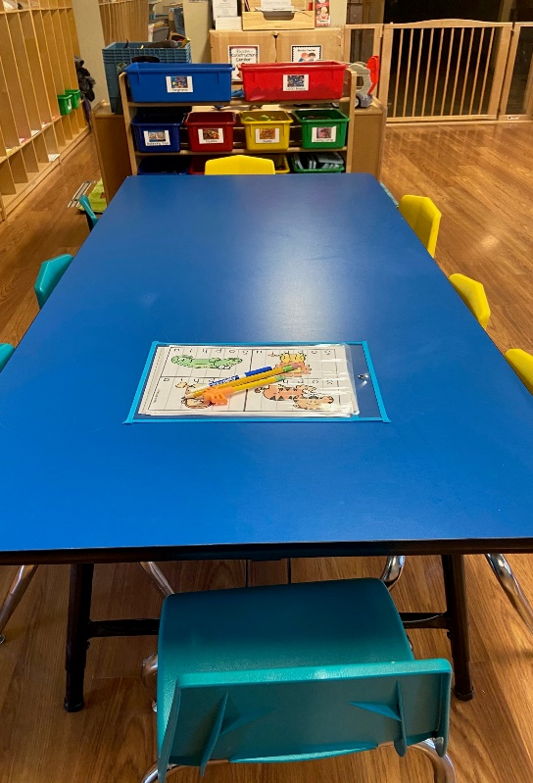
These are our classroom tables where we sit to do activities, play games, practice writing skills, eat snack and lunch, and work on art or other projects.
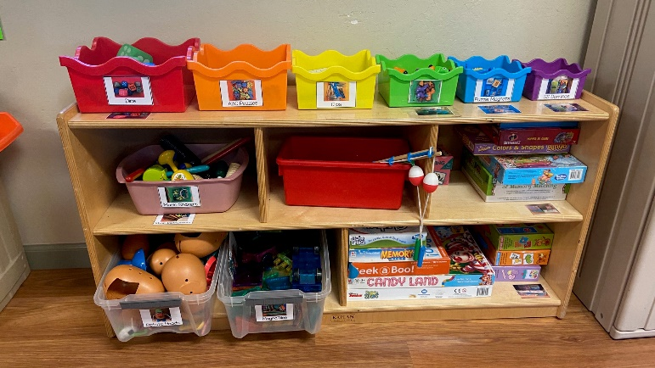

This is one of our storage areas where we keep games
and other center activities. Everything in the classroom
is labeled with a picture and a name for easy access and
cleanup.
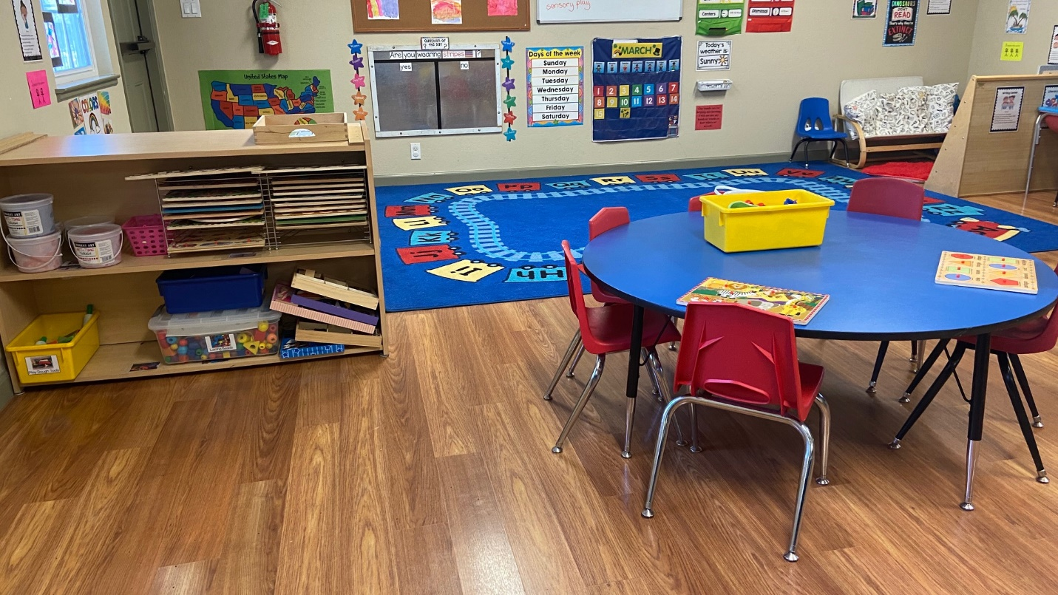
This table is where we set up puzzles or playdough for the children to use during center time. The shelf pictured has lot of puzzle options. We also have 6 colors of playdough and lots of tools to use with it!

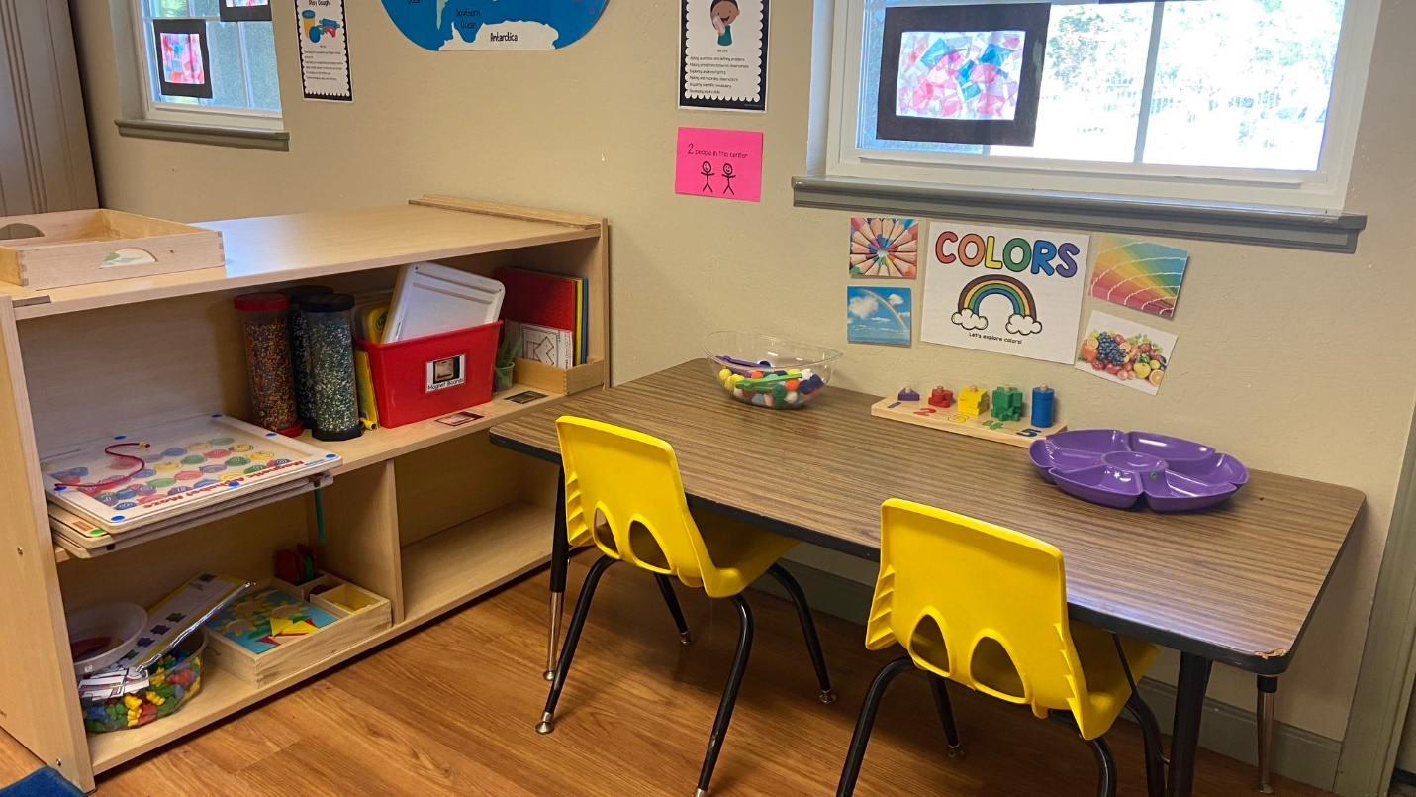
This is our Science Center. Every month I put a new theme out for the children to explore. The different items on the shelf will coincide with whatever the theme is for that month.

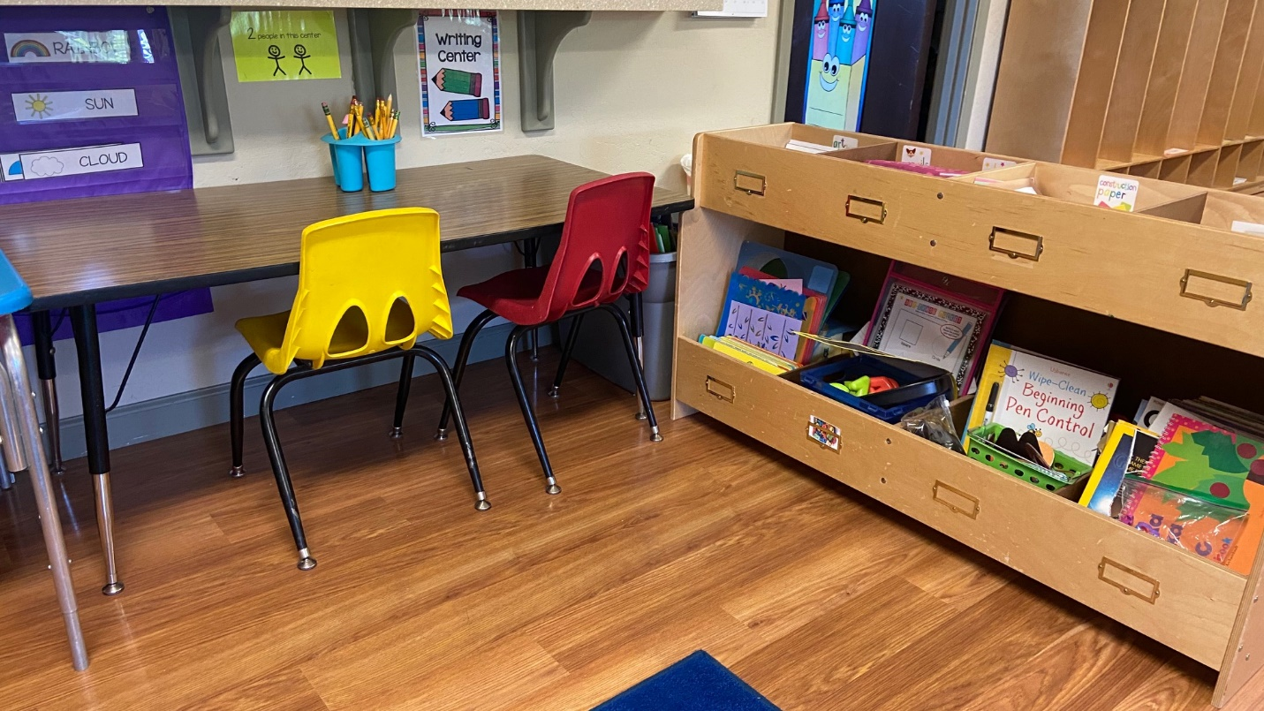
This is our Writing Center. In the storage unit I keep crayons, markers, pencils, scissors, glue, stickers, several different kinds of paper, and also coloring pages. The students can sit at the table and write and trace, or they can color a picture, or draw their own designs. They have free reign to just create and practice writing skills.

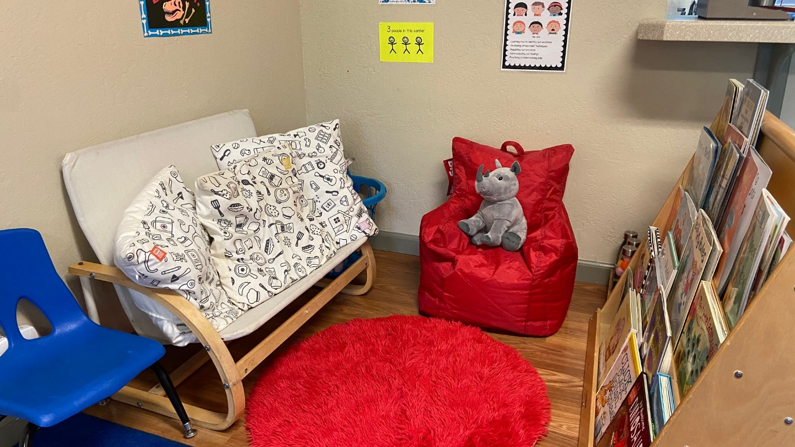
This is our calming corner and Reading Center. The books are changed out seasonally, and the soft items are washed weekly. There are sensory bottles in the corner that the students can use anytime they want. This corner is meant to be a quiet, safe space, where children can go when they feel overwhelmed or sad. It is open all day, regardless of the activities that are going on through out the day.
The next two pictures show our Circle Time Area. We have Circle Time in the mornings and afternoons. During our morning Circle, we will go over the days of the week, the weather, any special holidays or events going on, and we also do a Question of the Day that the children get to answer by placing a star with their name on it under the correct answer. In the second Circle time of the day, we read stories, talk about our day, sing songs, and have share time.
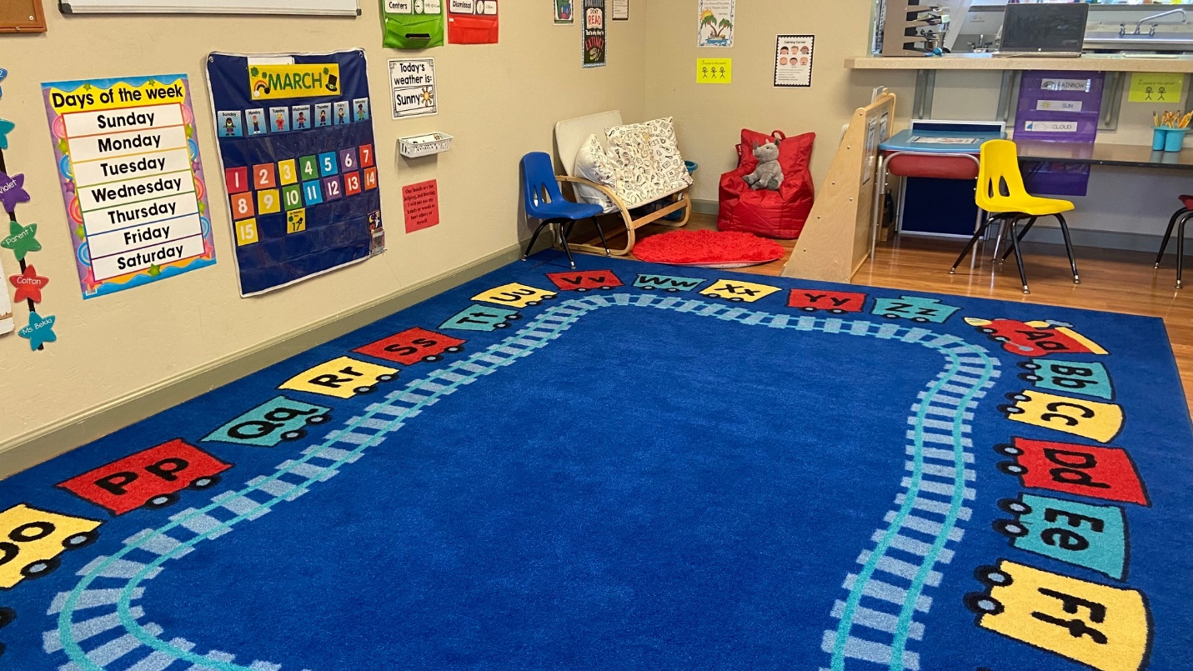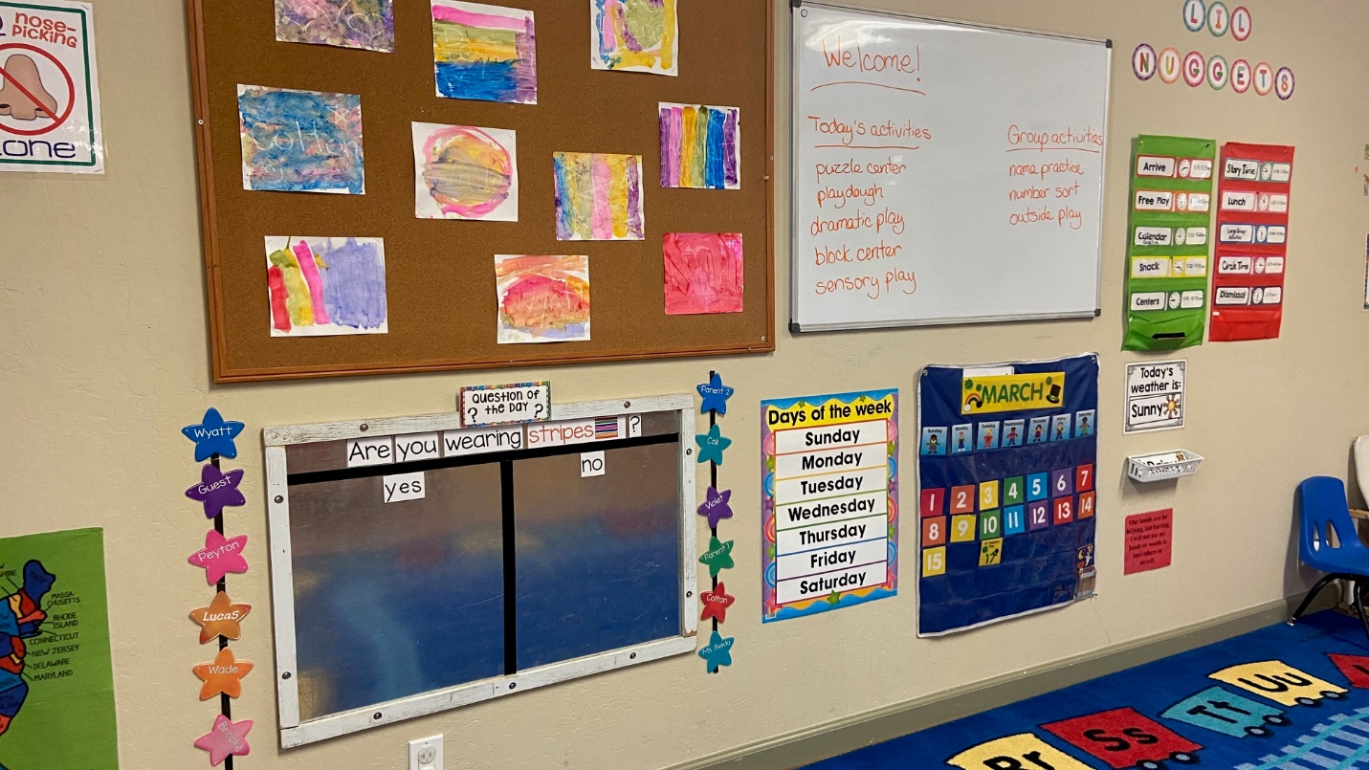

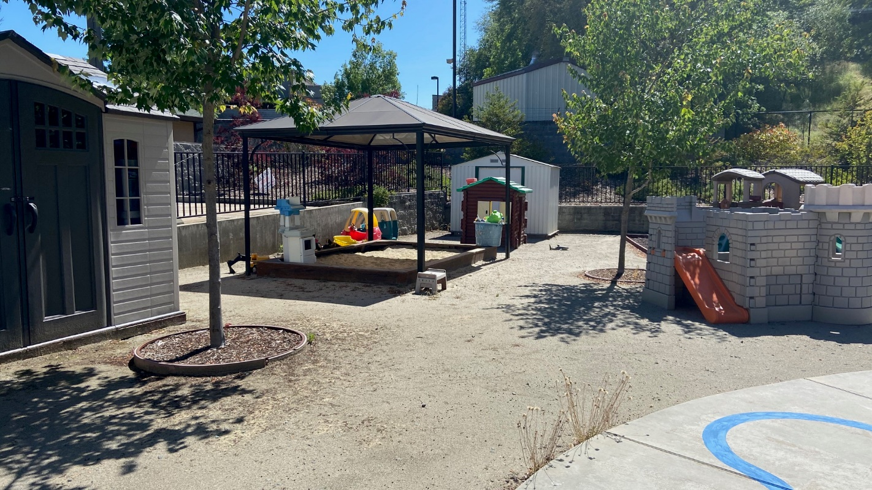
This is our current outdoor play area. The sand box is a class favorite and is used everyday! We usually go outside right after lunch, and we will only skip outside play if the weather is really bad. Which means extreme heat or cold. We have a plan in place to upgrade our playground in the future, and we will be hosting several fundraisers to fund that project.
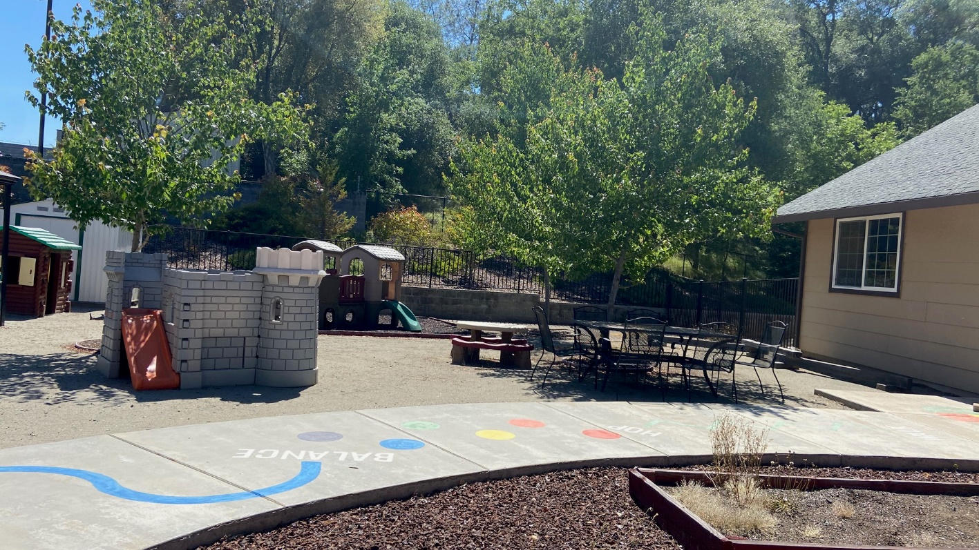

That is the end of the picture tour. I hope you enjoyed peaking into our little classroom! Please email me at rjoribello@gmail.com if you have any questions! Thank you!

